Questions for Eyke:
- What is the model of the Fully Differential Op-Amp that we will be using?
  - THS4521 or THS4561
    - In LTSpice Simulation I have used THS4561
  - What is PD with a bar on top?
    - Power down – what should I connect here?
- In the P (+) output terminal of the Fully Differential Op-Amp, there should be the negation in the output, but it is not explicitly shown in the symbol – is this okay?
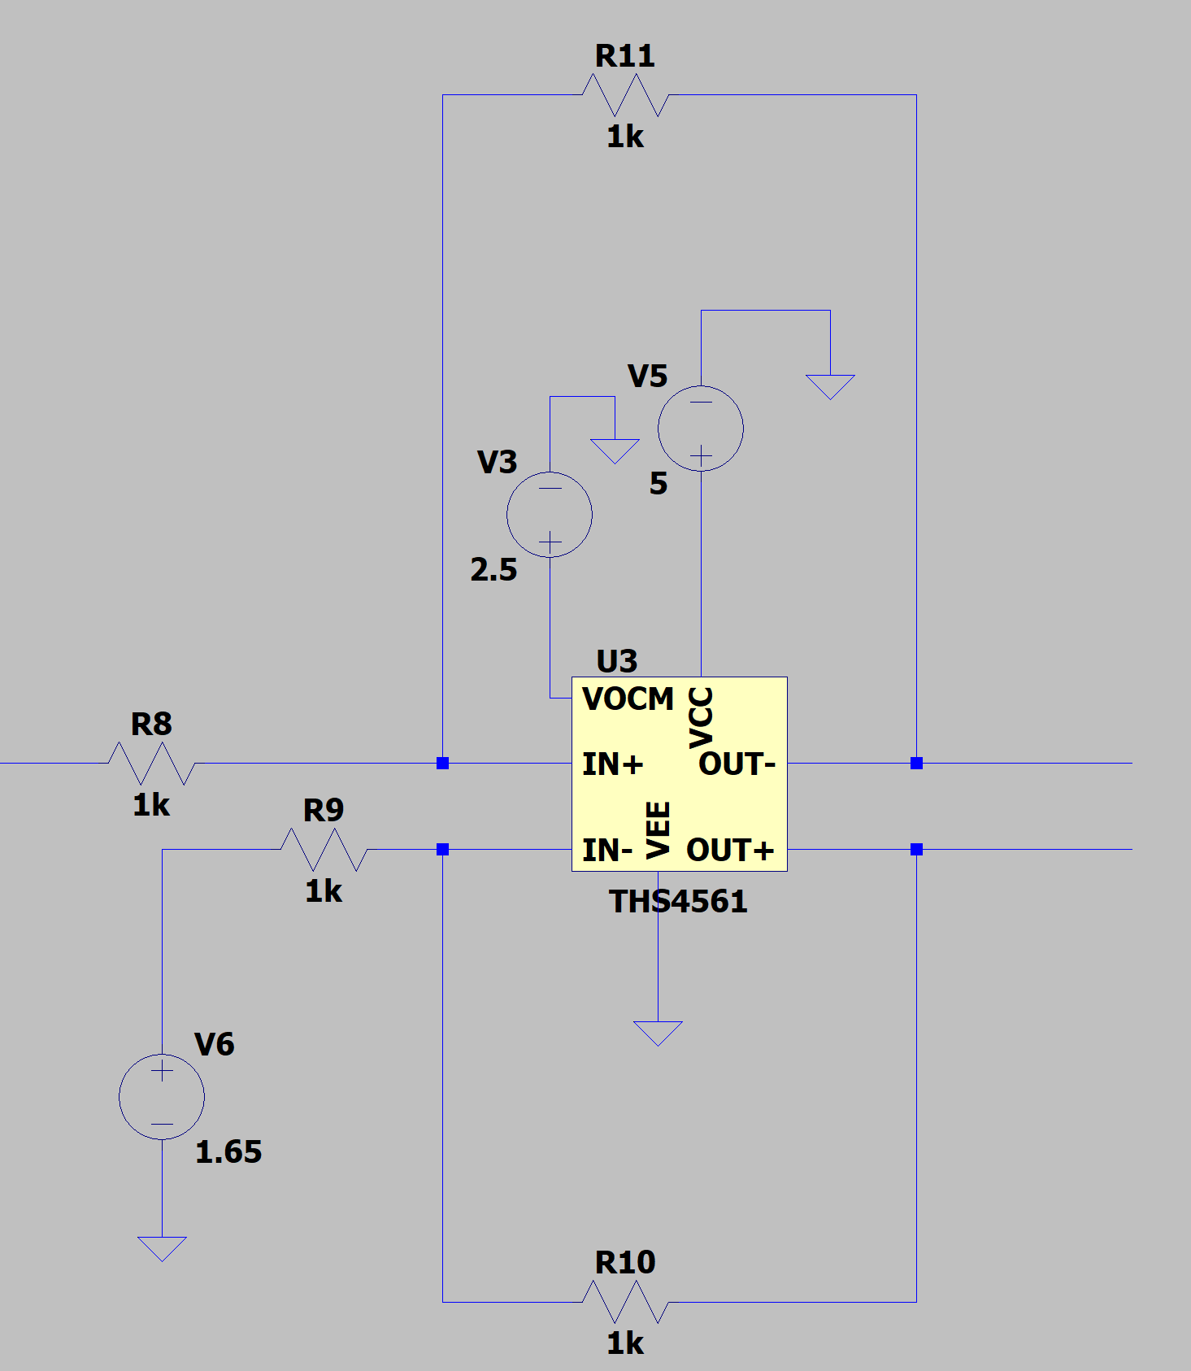
- Bitbucket references – Naming Conventions
- Naming convention for components on Altium – is it okay to have for example multiple R1s across multiple schematic sheets?
- For the HSEC8 connector pin, should I connect all unused pins to GND or is it okay if I leave them all floating?

Need to do – theoretically calculate the feedback of the fully differential op amp to give an output that is double ended.

For the AND Gate TI IC used
Datasheet: https://www.ti.com/lit/ds/symlink/cd4068b.pdf?ts=1736344168456

To Dos:
- Simulate all the connections to the AND Gate and also the Ethernet port RJ45?? So make sure all the voltage levels are correct.

